Required practical activity: Use a ruler and balance, the displacement method, and measurements of volume and mass to determine the density of a regularly shaped solid, an irregularly shaped solid, and a liquid.
Required Practical Guide – Density

Aim: To investigate density of regularly and irregularly shaped solids and liquids using a range of appropriate apparatus.
Notes and guidance
Discuss this practical with your technician colleague in advance to establish what resources are available.
This practical consists of three individual experiments. You may wish to organise the lesson such that groups move between stations where equipment for each practical is located. This will result in fewer resources used and less confusion over equipment. Let your technician colleague know in advance how the room should be set up.
Though no hazardous substances are used in this practical, it is likely there will be a lot of spillages of water. Ensure plentiful paper towels and a mop are available just in case.
Regularly shaped cubes of various materials can be purchased from most scientific suppliers; however they are not strictly necessary for this practical. Any regularly and irregularly shaped objects will suffice, as long as they are made from one material.
Remind students of correct units to use in measurement before the experiment. In particular, it is always useful to remind them that 1 ml = 1 cm³.
Risk Assessment Notes
A risk assessment must be completed for this practical. The risk assessment should be specific to the class involved and written only by the teaching member of staff. For more guidance refer to CLEAPSS. It is good practice for students to wear safety spectacles during all class practicals and demos.

Water spillages should be cleaned up immediately as they are a tripping hazard. Take care to not spill water on mass balances.
Method (part 1 – regular shaped objects)
- Use the ruler to measure the length, width, and height of each of your selected regular shaped objects. Record this data in your results table.
- Calculate the volume of each object and record this in your results table also.
- Use the digital mass balance to measure the mass of each of your objects. Record this in your results table.
- Calculate and then record the density of the objects using the equation: density = mass/volume.
- Convert your density measurements into the standard units of kg/m³.

Results Table (part 1)
Regular  Shaped  object | Length (cm) | Width  (cm) | Height  (cm) | Volume (cm³) | Mass  (g) | Density  (g/cm³) | Density  (kg/m³)

Method (part 2 – irregular shaped objects)
- Use the digital mass balance to measure the mass of one of the irregular shaped objects. Record this mass in your table.
- Secure the displacement can in the clamp stand so it is well-supported, and the spout is just higher than the top of your measuring cylinder. Select a measuring cylinder of an appropriate size for the object you will be measuring.
- Place an empty beaker beneath the spout of the displacement can. Carefully fill the displacement can with water until water leaks from the spout into the beaker. Wait until the spout stops dripping before proceeding to the next step.
- Remove the beaker and place your measuring cylinder beneath the spout.
- Slowly and carefully lower the irregular shaped object into the displacement can. You may wish to use a short length of cotton to do this to avoid having to drop the object and cause a splash.
- Measure and record the volume of water displaced from the can to the measuring cylinder. This will be equal to the volume of the object.
- Calculate and record the density of the irregular shaped object.
Results Table (part 2)
Irregular shaped object | Volume (cm³) | Mass  (g) | Density  (g/cm³) | Density  (kg/m³)

Method (part 3 – liquid)
Use the digital mass balance to measure the mass of an empty 100 ml measuring cylinder.
Add approximately 100 ml of salt solution to the measuring cylinder and record the exact volume in your results table.
Calculate and then record the density of the liquid using the equation: density = mass/volume.
Convert your density measurements into the standard units of kg/m³.
Results Table (part 3)
Liquid | Volume (cm³) | Mass  (g) | Density  (g/cm³) | Density  (kg/m³)

Equipment:
PART 3
PART 2
PART 1
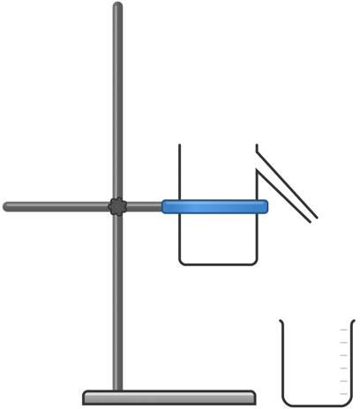
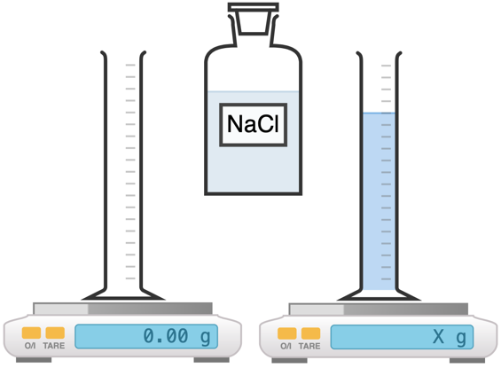
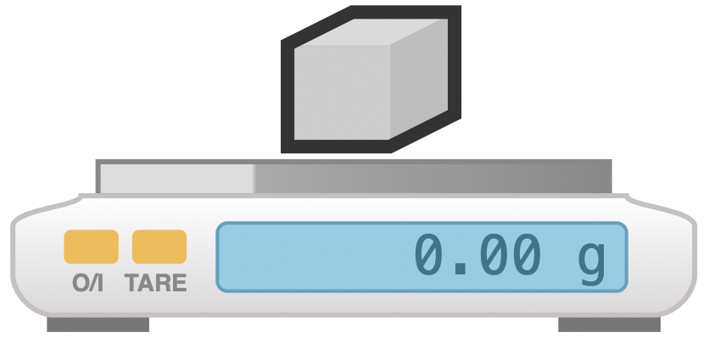

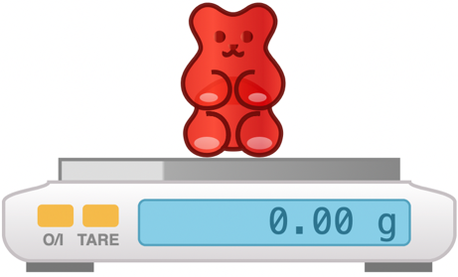
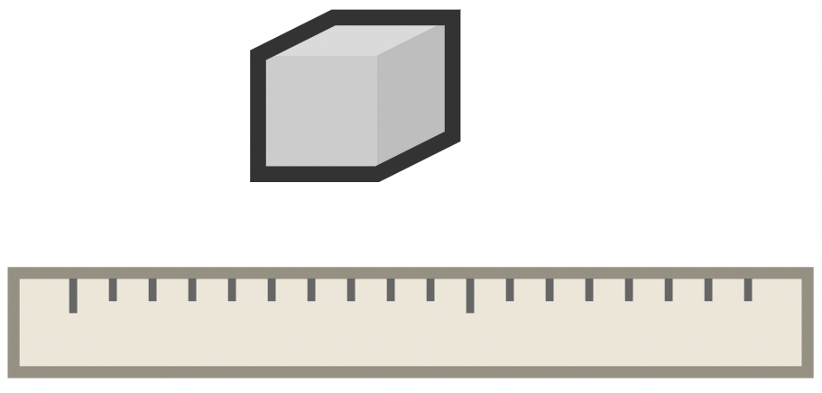

Clearing up
It is important that equipment is returned to the prep room in good order. Return everything back to the tray it came in neatly.

If the trays arrived on a trolley, students must return all trays and equipment to that trolley.

Salt solution can leave stains if spilled. Ensure any spills are properly wiped and/or mopped up.
Questions To Ask Students
- What is the equation for volume of a regular shaped object? (Volume = length x width x height)
- What is the equation for density? (Density = mass / volume)
- Why is it important to lower the irregular shaped object into the displacement can slowly and gently? (To avoid splashes – the only water lost from the can should be due to displacement from the irregular shaped object.)

Technician Notes
Regularly shaped cubes of various materials can be purchased from most scientific suppliers; however they are not strictly necessary for this practical. Any regularly and irregularly shaped objects will suffice, as long as they are made from one material.
Any irregular shaped object used for this practical must fit into a displacement can and also be made of a material more dense than water (such that it will sink and become fully submerged inside the can).

Other solutions can be used for the liquid part of this practical. Sugar water is a good substitute for sodium chloride solution, though if spilled it can leave a sticky residue.

Discuss this practical with the class teacher beforehand to ensure they have a clear idea of the three separate experiments. They may wish to conduct this practical as a carousel with stations for each experiment.

